**Assignment 3**

* Due Apr 27, 2016 by 11:55pm
* Points 20
* Submitting a website url
* Available Apr 21, 2016 at 7:40pm - Jun 17, 2016 at 11:59pm about 2 months

**Prog 109 Assignment 3: Blog page with HTML5 Semantic Elements and CSS Stylesheet**

**Description:**

You will use your latest mark-up skills to create a one page HTML document that contains a blog of some kind. You've seen these all over the web -- now it's your turn to create something that the world will beat a path to your website to read! It can be virtually *any* topic you choose: health and fitness, technology, film reviews, lego architecture, life on other planets, whatever. As an example, here's an idea for a travel blog page that I created:

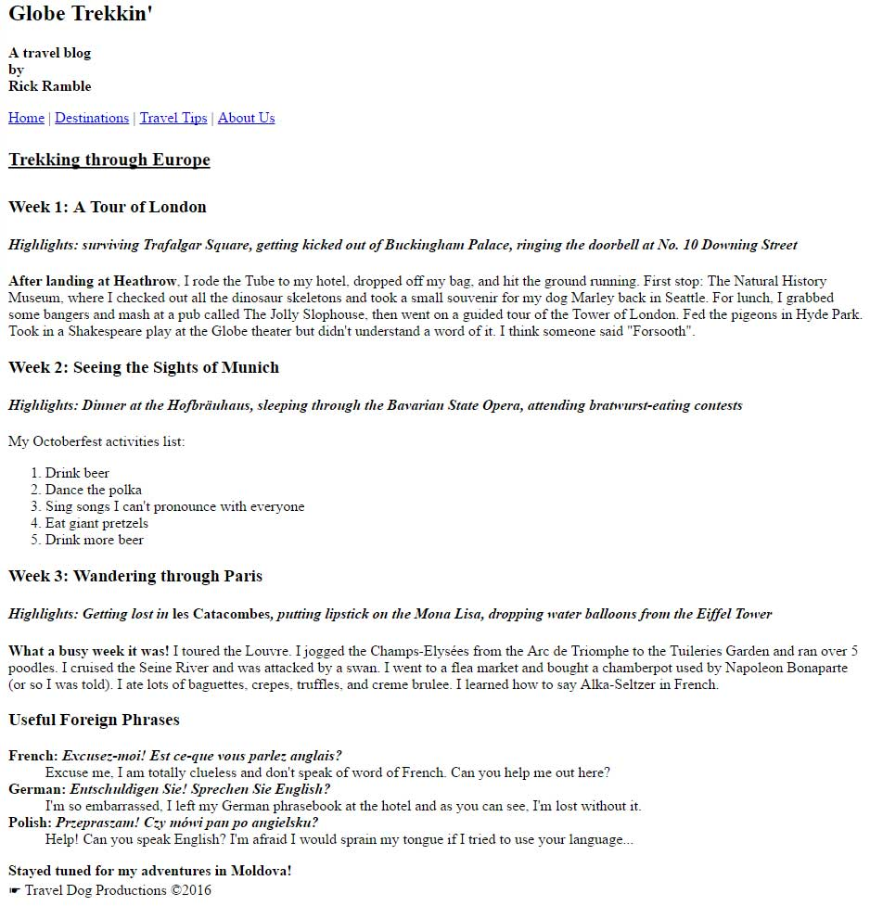

A good start, but it looks rather plain. What it needs is some CSS to enhance the visual appeal and HTML5 semantic (or sectioning) elements to organize the code and make the HTML document more readable. For this assignment, you will be using HTML5 sectioning elements to organize your own blog page (like the tags we covered in class:  **header**, **section**, **article, nav,** and **footer**). You will also add CSS for the formatting and validate the page using an HTML5 validator.

**Details:**

1. Your blog document should include the following tags: **header**, **footer**, **section**, **nav** and  **article**. You may include other HTML5 semantic elements if you wish to do so. NOTE: The **nav** is just a mockup -- it doesn't have to link to anywhere (just create some dummy page links). Your blog also doesn't have to be as wordy as the example above, *but you must include at least 2 article topics*.
2. Style the document using a CSS stylesheet. It is not necessary to link to external styles yet, even if you already know how to do this. But you *must* use an **internal** style sheet at least. NOTE: *If you plan on using any inline styles, ask me first otherwise your assignment will be downgraded!*
3. These CSS properties are required in your page: **text color, font size, font-family, background color, margin, padding,**and **border**(be sure to use all 3 border values: width, style, and color to get full credit). You may need to use your book, module content, or reference the web to find out the exact syntax for some of these properties. You may include additional properties if you wish to do so.
4. Use each of these selector types at least *once* in your CSS stylesheet: **tag**, **class,** and either a**descendant selector** or **child selector**. If you're not sure how to use any of these, feel free to post questions to the Discussion forum. The textbook also has a list of good examples on p. 238.
5. You will also need to validate your document using the**W3C HTML5 validation service**. Here is the link: [http://validator.w3.org/ (Links to an external site.)](http://validator.w3.org/). I will review each submission to see if it validates and is error free. In the event you are unable to make your page validate,  include a comment in your document explaining the validation error. Again, feel free to use the Discussion forum to post questions about any of the generated error messages you are unclear about -- from experience, I know they're not all obvious, so we can help each other here.
6. Finally (whew!), your blog page must include at least 1 **<img>** element (properly coded with the 2 required attributes, of course). In addition to an <img> element, you can also add a background-image if you want. All images must be placed in a separate directory (standard professional web development practice). Call it *images* or something similarly reasonable.
7. **Optional challenge**: Use the **float** property or *flexbox* properties to position sidebar information inside of an HTML5 **aside** element. The sidebar should be positioned adjacent to your main blog content (that is, side by side). This is called a *two column layout* in web design lingo. NOTE: As per our class discussion, you may  find it easier to achieve this layout using flexbox. For a bigger challenge, try building a multiple column layout using float.

**Submission:**

Upload the assignment to your website. You can put it in a separate subdirectory if you like. Once posted, you will want to test it in your browser to make sure it still displays as you intended. In general, it is always a good idea to test websites with more than one browser (the major non-mobile browsers are: Chrome, Firefox, Safari, IE, and Opera).

**The Blog Makeover:**

Here is the example from above enhanced with CSS and HTML5 sectioning elements — plus a few other touches. There is a lot more going on here than what you need to do, but you can see how CSS can totally transform a page. If there are any features on this page that you would like me to cover in class, just let me know.

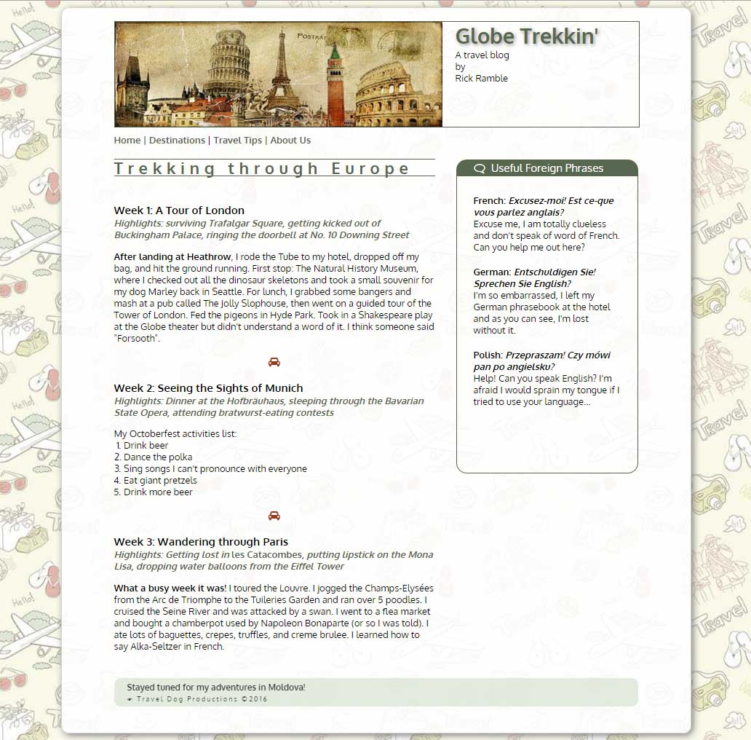

**Rubric**

| PROG109: Assignment 3 | | |
| --- | --- | --- |
| **Criteria** | **Ratings** | **Pts** |
| This criterion is linked to a Learning Outcome Code Formatting  Is the code formatted correctly? Are the HTML elements closed correctly? Are there different sections to the code (head/body)? Did you use any white space or indenting to make the HTML and CSS readable? | |  |  | | --- | --- | | 3.0 pts  Full Marks | 0.0 pts  No Marks | | 3.0 pts |
| This criterion is linked to a Learning Outcome Tags utilized  Were the required HTML5 tags utilized and were they utilized appropriately? For 'appropriate usage', consider the guidelines as discussed in class last week (and use common sense -- you wouldn't put header content inside a footer element, for example). See the assignment description for the required tags. Also, was an element used correctly? | |  |  | | --- | --- | | 5.0 pts  Full Marks | 0.0 pts  No Marks | | 5.0 pts |
| This criterion is linked to a Learning Outcome CSS properties utilized  Were the required CSS properties utilized? See the assignment description for the required CSS properties. Were *all* your CSS properties coded correctly? | |  |  | | --- | --- | | 6.0 pts  Full Marks | 0.0 pts  No Marks | | 6.0 pts |
| This criterion is linked to a Learning Outcome CSS selectors utilized  Were each of these CSS selectors used at least once: tag (element type), class, and descendant (or child)? Were all the CSS selectors properly placed in stylesheets so there were *no* styles imbedded in the HTML tags? | |  |  | | --- | --- | | 4.0 pts  Full Marks | 0.0 pts  No Marks | | 4.0 pts |
| This criterion is linked to a Learning Outcome Validation and submission  Does the assignment pass the W3C validator without errors? Or if there are errors, have they have been notated in your HTML document? Was the assignment submitted properly to your website? | |  |  | | --- | --- | | 2.0 pts  Full Marks | 0.0 pts  No Marks | | 2.0 pts |
| Total Points: 20.0 | | | |